**CS150 – Introduction to Computer Science I**

**Assignment 1** – save your file as *yourlastname*Diagonals.py

Topics: Assignment statements, mathematical operators, output

**Directions:**

Ask the user to input the number of sides on a polygon and determine the number of diagonals within the polygon.

Examples:

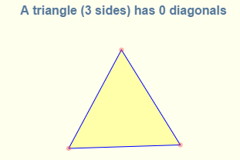 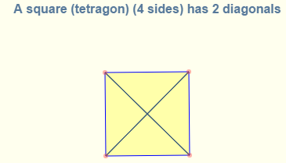 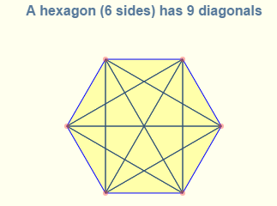

The formula to calculate the number of distinct diagonals is:

$$\frac{n(n-3)}{2}$$

Where n represents the number of sides (vertices). Do not use ‘n’ as your variable name for sides. Use a more descriptive variable name.

Write a plan for your solution before starting. Include comments at the beginning of the program to indicate the purpose, author, date, and filename. Include comments throughout the code to explain code.

Sample run: User input in bold

Determine Diagonals

----------------------------

Enter number of sides of a polygon: **10**

A 10 sided polygon has 35 diagonals

Notice that the number of diagonals is output as an int -- no decimals.

Test your code with various sides to make sure it is working correctly.

**Test Data**

|  |  |
| --- | --- |
| **Sides** | **Diagonals** |
| 5 | 5 |
| 6 | 9 |
| 12 | 54 |
| 20 | 170 |
| 30 | 405 |
| 50 | 1175 |

Save your file as *yourlastname*Diagonals.py and submit by the due date.